In order to protect our employees, the environment and our factory equipment, please do not only provide general information regarding the return, but also whether the product has been in contact with hazardous substances. This is necessary before we can process your order. Please include this declaration with the shipping documents and attach them to the outside of the packaging.
Consignor | Consignee
Company:  Street:  Place:  Contact:  Telephone No.:  Email:  Information concerning the valve/goods  Valve designation:  Article number:  Order number: | Schubert & Salzer Control Systems GmbH  Service Department  Bunsenstraße 38  85053 Ingolstadt, Germany  E-Mail: Info.cs@schubert-salzer.com  Preselection of media:  Steam:  Water:  Nitrogen:  Carbon dioxide:  Oxygen:  Other:

Reason for the return and the appropriate action
Repair Inspection Modification Claim Incorrect delivery/order Sample
Cost estimate required Please contact us Repair authorisation granted

Fault description
- Which part of the valve is defective?
Controller Valve seat Actuator Spindle bushing Other
- Fault description:
- Fault frequency: The fault occurs frequently The fault only occurs sporadically

Contamination and protective measures

The valve/product was not in use. The valve/product did not come into contact with hazardous substances.

The valve/product came into contact with the following hazardous substance(s):
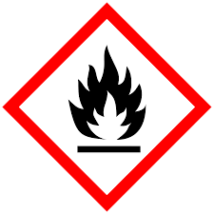Flammable | 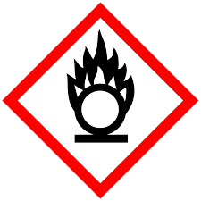Oxidising | 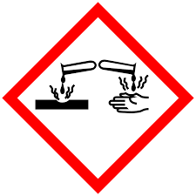Caustic | 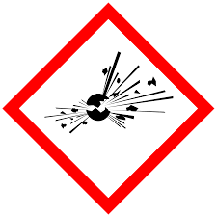Explosive | 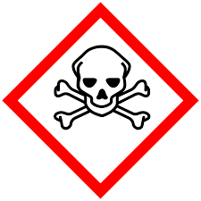Toxic | 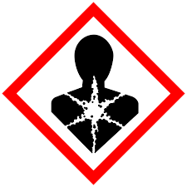Hazardous for the Health | Irritant or sensitising | 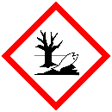Hazardous for the Environment

If the goods have come into contact with hazardous substances, please send us the safety data sheet in German or English.

The valve/product was cleaned on the inside and the outside.

The processing does not require any special safety precautions.

The processing requires the following safety precautions:
Protective goggles | Protective gloves | Face protection | Protective clothing | 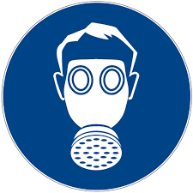Breathing protection

Place, Date: Signature:

By signing this form, you are confirming that your information is correct and complete.

